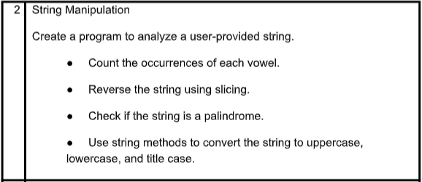
==============================================================================
COMMAND:
'''String Manipulation
Create a program to analyze a user-provided string.
● Count the occurrences of each vowel.
● Reverse the string using slicing.
● Check if the string is a palindrome.
● Use string methods to convert the string to uppercase,
lowercase, and title case.'''

# Get input from the user
text = input("Enter a string: ")

# Convert to lowercase for consistent processing
lower_text = text.lower()

# Count vowels
a_count = lower_text.count('a')
e_count = lower_text.count('e')
i_count = lower_text.count('i')
o_count = lower_text.count('o')
u_count = lower_text.count('u')

print("Vowel counts:")
print("a:", a_count)
print("e:", e_count)
print("i:", i_count)
print("o:", o_count)
print("u:", u_count)

# Reverse the string using slicing
reversed_text = text[::-1]
print("Reversed string:", reversed_text)

# Check if the string is a palindrome (ignoring case)
if lower_text == reversed_text.lower():
print("The string is a palindrome.")
else:
print("The string is not a palindrome.")

# Convert and display different cases
print("Uppercase:", text.upper())
print("Lowercase:", text.lower())
print("Title case:", text.title())

OUTPUT:
